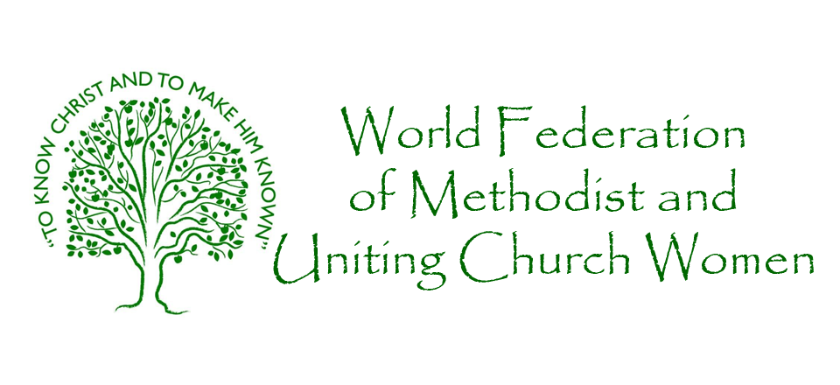North America Area Seminar
October 3-6,2019
Northbrook, IL

Dr. Sandra L Gadson President

THEME: Chosen People: Called to Proclaim

Hilton Chicago/Northbrook
2855 N. Milwaukee, Avenue
Northbrook, IL 60062
HOTEL INFORMATION
Contact: Reservation Agent: Marcela Rosillo email Marcela.Rosillo@hilton.com HOTEL CUT-OFF DATE:
September 23, 2019

(closest airport: Chicago O’Hare)

$110.00per night  Single/double occupancy | $120.00 per night  Triple Occupancy | $130.00 per night  Quadruple occupancy
(Nightly rates include breakfast, tax and program)

REGISTRATION INFORMATION
REGISTRATION FORM
FEE: $150.00 payable to World Federation of Methodist and
Uniting Church Women of North America
(includes 2 lunch and 3 dinner meals and program)
REGISTRATION: Thursday, October 3,2019 1:00 p.m. – 7:00pm
Seminar starts with Dinner Thursday, October 3,2019
ends Sunday, October 6,2019 at Noon (lunch is not included)
REGISTRATION DEADLINE: September 30, 2019

MAIL TO: Ms. Cynthia Revels-Young 31 Doty Street ~ Hammond, Indiana 46320

(Please TYPE or PRINT)
NAME:
ADDRESS:
CITY: | STATE: ZIP:
TELEPHONE: | EMAIL:
REGION: | STATE:
CIRCLE ONE: AME AMEZ CME MCCA UMW OTHER:

TRAVEL INFORMATION

Please fill out this information and return it with your registration form to Ms. Cynthia Revels-Young. Thank You

NAME: _________________________________________________________

CELL PHONE NUMBER _______________________________________

MODE OF TRANSPORTATION: _____________________________

IF ARRIVING BY AIR, PLEASE PROVIDE THE FOLLOWING INFORMATION:

AIRLINE: _________________________________________________________

FLIGHT NUMBER: ________________________________________________

ARRIVAL DATE: ______________________ ARRIVAL TIME: _______________________________

DEPARTURE DATE: __________________ DEPARTURE TIME: ___________________________

